Churod contactors help power the way for University of Michigan FSAE team podium finish
8 August 2022, Ann Arbor, MI
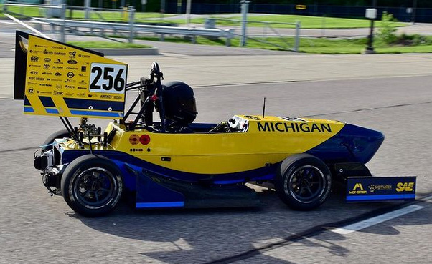
Congratulations to MRacing from the University of Michigan for an outstanding finish in the 2022 Formula SAE EV competition! The competition pitted electric open-wheel race cars from 58 universities to see whose car was the best in speed, design, endurance, and more. The Wolverines finished a remarkable second place (first in the US for the fourth year in a row) and third place overall for best design, receiving glowing praise from the judges for having the best powertrain in the competition.
Churod Americas was honored to sponsor the MRacing team this year. Support came in multiple forms including providing our CHEV series hermetically sealed high voltage DC contactors for use in the power management system. The CHEV worked exceptionally well in the design. “We're really happy with how they performed!” said Nicholas Chan from the MRacing Powertrain Engineering group. “One issue we've had in the past was with high inrush currents with our contactors affecting our low-voltage systems. We've found that the economized coils on the CHEV-112 contactors have no overshoot at all, completely solving this issue.” The contactor provided was rated for 250A@750VDC, but the CHEV family has solutions for currents from 60A-600A and voltages to 1000VDC. Churod is a proud sponsor of the MRacing team, and we look forward to helping the team to reach its goals during the upcoming 2023 season and beyond!
Churod Americas is a wholly owned division of Dongguan Churod Electronics Co., Ltd., a leading manufacturer of relays for appliance, automotive, industrial, and new energy applications. With a focus on relays for green energy products, Churod designs cutting-edge solutions for solar, battery, and high voltage DC systems. Churod has four manufacturing campuses in China along with offices and sales support around the world. At Churod, “Everything we do is for our customers’ advantage.”

